Year 2 Great Wondering Brainstorm

Step 1: Identify areas of strength and areas for potential growth

HRS Level 1 – Safe & Collaborative Culture
Leading Indicators | Mean(s) | Lagging Indicators (Evidence) | Strength | Area for Growth
  - The faculty and staff perceive the school environment as safe and orderly.

  - Students, parents, and the community perceive the school environment as safe and orderly.

  - Teachers have formal roles in the decision-making process regarding school initiatives.

  - Teacher teams and collaborative groups regularly interact to address common issues regarding curriculum, assessment, instruction, and the achievement of all students.

  - Teachers and staff have formal ways to provide input regarding the optimal functioning of the school.

  - Students, parents, and the community have formal ways to provide input regarding the optimal functioning of the school.

  - The success of the whole school, as well as individuals within the school, is appropriately acknowledged.

  - The fiscal, operational, and technological resources of the school are managed in a way that directly supports teachers.

HRS Level 2 – Effective Teaching in Every Classroom
Leading Indicators | Mean(s) | Lagging Indicators (Evidence) | Strength | Area for Growth
2.1 The school leader communicates a clear vision as to how instruction should be addressed in the school.

2.2 Support is provided to teachers to continually enhance their pedagogical skills through reflection and professional growth plans.

2.3 Predominant instructional practices throughout the school are known and monitored.

2.4 Teachers are provided with clear, ongoing evaluations of their pedagogical strengths and weaknesses that are based on multiple sources of data and are consistent with student achievement data.

2.5 Teachers are provided with job-embedded professional development that is directly related to their instructional growth goals.

2.6 Teachers have opportunities to observe and discuss effective teaching.

Notes: _______________________________________________________________________________________________________________________________________________________________________________________________________________________________________________________________________________________________________________________________________________________________________________________________________________________________________________________________________________________________________________________________________________________________________________________________________________________________________________________________________________
School Culture Data (from April Seminar)

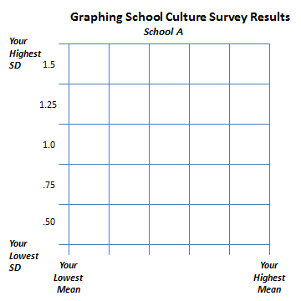

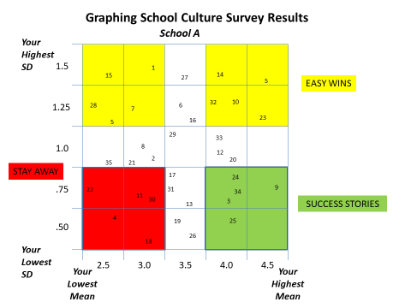

Other Available Data (AdvancEd surveys, district surveys, assessment data, etc.)

District Initiatives or Ideas from Seminars/Conferences:
_________________________________________________________________________________________________________________________________________________________________________________________________________________________________________________________________________________________________________________________________________________________________________________________________________

What is the one thing your team thinks it could change within the next few months that would have a significant impact on your school?
______________________________________________________________________________________________________________________________________________________________________________________________________________

Step 2: After reviewing the data and identifying areas of strength and areas for potential growth, list 5-8 wonderings (questions) the team may have. Here are some examples:

- Low scores on HRS 1.3 (teacher input in decision making) and School Culture Collaborative Leadership: How can the implementation of a building leadership team improve decision making and buy-in on major initiatives?

- Low scores on HRS 1.4 (teacher teams and collaborative groups/PLCs) and School Culture Teacher Collaboration: How do we as a team lead our faculty and staff in the development of professional learning communities? OR How can the development of professional learning communities improve our ability to address common issues regarding curriculum, assessment, instruction, and the achievement of all students.

- Low scores on HRS 1.6 (students, parents, and the community input) and School Culture Learning Partnership: How can the development of formal ways to provide input from students, parents, and the community improve optimal functioning of our school?

- Low scores 2.3 (predominant instructional practices): How can the development of an instructional snapshot (what we should always see; what we should sometimes see; what we should never see) improve instruction in our school?

- Low scores on HRS 2.6 (opportunities to observe others) and School Culture Teacher Collaboration: How can the implementation of instructional rounds improve instruction in our school?

______________________________________________________________________________________________________________________________________________________________________________________________________________________________________________________________________________________________________________________________________________________________________________________________________________________________________________________________________________________________________________________________________________________________________________________________________________________________________________________________________________________________________________________________________________________________________________________________________________________________________________________________________________________________________________________________________________________________________________________________________________________________________________________________________________________________________________________________________________________________________________________________________________________________________________________________________________________________________________________________________________________________
___________________________________________________________________________________________________________________________________

Step 3: Answer the following questions:
- Which of your wonderings do you feel is most important to explore at this time in order to improve our school? Place an “I” by those.
- Which of your wonderings do you feel is least important to explore at this time in order to improve our school? Place an “L” by these.
- Which ones of your “most important” are doable this year (November-April) as part of IPLI? Place a “D” by those.

Step 4: Select a wondering
- IPLI Team selects OR Share your list of possible wonderings with faculty and have them provide input into which wondering to select.

Our wondering is: _________________________________________________________________________________________________________________________________________________________________________________________________________________________________________________________________________________________________________________________________________________________________________________________________________
___________________________________________________________________________________________________________________________________

Step 5: Conduct the Wondering Development Litmus Test

Wondering Development Litmus Test
*Is your team’s wondering something they are passionate about exploring?
*Is your team’s wondering focused on increasing the leadership capacity of your
school?
*Is your team’s wondering a REAL question (a question whose answer is not known)?
*Is your team’s wondering focused on your own school’s practice?
*Is your wondering phrased as a dichotomous (yes/no) question?
*Is your team’s wondering specific?

Bring the question your team developed to your October Regional Focus-Cohort meeting.

Resources: Chapter 2 of Leading with Pasion & Knowledge and Chapter 3 of The PLC Book
