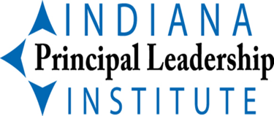
IPLI BIG IDEAS

YEAR 1 – INCREASING LEADERSHIP CAPACITY

Focus on Self
Improving Instructional Leadership
Increasing knowledge and Skills as a Leader
Ideas such as “Shifting the Monkey” from What Great Principals Do Differently
10-Minute In-service Ideas (Annette Breaux)
Time Management
School Culture
Finding Balance
Improving Communication
Shared Leadership/Developing Leadership Capacity within School

YEAR 2 – INCREASING THE LEARNING CAPACITY OF THE SCHOOL

Focus on School
Level 1  Safe and Collaborative Culture | Level 2  Effective Instruction in Every Classroom | Level 3  Guaranteed and Viable Curriculum & Vocabulary Program | Level 4  Standards- Referenced Reporting | Level 5  Competency- Based Education
School Safety Plan | Instructional Framework | Curriculum alignment | Essential elements | Students move on to the next level only after demonstrating competence
PBIS | Instructional Rounds | Priority Standards | Proficiency scales for each EE
Discipline Policy | Coaching | Guaranteed | Goals - school
Alternatives to suspensions and expulsions | Highly Specific Instructional Rubrics | Viable | Goals – students | Schedule accommodates student needs
PLCs | Job-embedded PD | Comprehensive Vocabulary  - Each grade level/content area | Self-assessment-assessment capable learners
 |  |  | Data used to monitor progress | Students demonstrating competency immediately afforded opportunities to work on advanced content
Leadership Team | >Classroom observations  - Formal  - Informal  - Effective Feedback
>Communication
 |  | Direct instruction in knowledge application & metacognitive skills | Team analysis of data
>Parent Engagement
>Input

