PRINCIPAL-TEACHER TEAM IPLI ACTION
RESEARCH CYCLE
2020 - 2021
______
SEPTEMBER SHARING LEARNING: THE AR MINI-CYCLE
SEMINAR (9/22)

In addition to some great learning through keynoters at this meeting, you will meet with your mentor in your regional cohort groups to touch base with one another as well as share what you learned through the completion of your team mini-action research cycle.

At the Summer Seminar, you received The PLC Book. This book is a resource to help you work with your two teacher-leaders in the development of your team’s action research project. It parallels the book you used last year to guide you through your personal AR cycle.

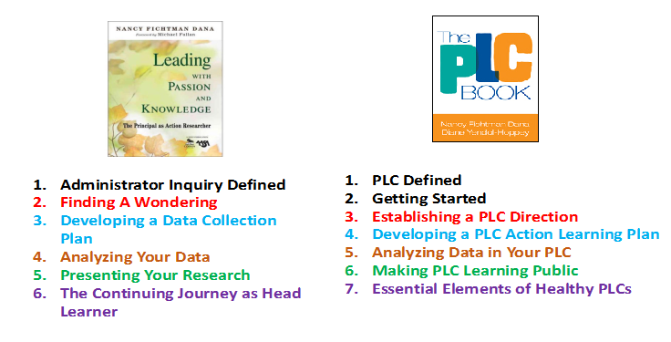

To Do in Preparation for October Regional Focus-Cohort Meeting: In essence, you and the two teachers you have selected to join you this year in IPLI now constitute a small Professional Learning Community who will engage in a collaborative action research project this year focused on school improvement. Just as you developed a wondering for your personal AR cycle focused on your own leadership practice in IPLI last year, this year you will work with your teachers to develop a question to guide your PLC work. To aid in this process, read Chapters 1-3 of The PLC Book with your teachers, discuss the chapters together, and develop a single question to guide your learning together as a small PLC this year. As you develop your wondering, please keep in mind the following:
- The PLC Book is written for teacher teams versus a leadership team, but the process is the same. The book is simply a guide. You may also wish to refer back to Leading with Passion and Knowledge from last year.
- Your AR project should focus on increasing the learning capacity of your school.
- Development of your wondering should come from your HRS and other available school data (strengths and areas for potential growth).

The Great Wondering Brainstorm for Teams: Based on your team’s review of Level 1 and Level 2 HRS data, list a few wonderings that have emerged from the data. Once your list is complete, as a team, review the entire list and place stars next to the three wonderings that you feel would be most important for your team to explore through the process of inquiry this IPLI year. When you return to your school, share your top three wonderings with your faculty and staff. Discuss both the wondering itself and your reasons for selecting that wondering as one of your top three choices for exploration through the process of inquiry. As a faculty, select one wondering to explore.

Wondering Development Litmus Test
*Is your team’s wondering something they are passionate about exploring?
*Is your team’s wondering focused on increasing the leadership capacity of your
school?
*Is your team’s wondering a REAL question (a question whose answer is not known)?
*Is your team’s wondering focused on your own school’s practice?
*Is your wondering phrased as a dichotomous (yes/no) question?
*Is your team’s wondering specific?

Bring the question you developed with your teachers to your October Regional Cohort meeting.

OCTOBER REGIONAL DEVELOPING YOUR WONDERING
FOCUS-COHORT
MEETING

The purpose of this meeting is to work together with your fellow regional cohort member principals and mentor to help each other fine-tune the question you developed for exploration with your teachers and to offer one another resources that are related to the topic of each school-improvement AR project. A goal to strive for is to have each member of your regional cohort leave this meeting with a well-defined, quality wondering for their team AR project (A guiding question for their PLC).

To Do in Preparation for the November Seminar:

Read Chapter 4 of The PLC Book. Adapt as needed and apply the process “Kevin” used in the book with his PLC (pp. 45-54) to develop a plan for the AR work you will complete with your teachers for IPLI this school year. As a part of or after your team meeting, design an “Inquiry Brief” (a brief, one-two page outline of your PLC’s plan of action) and bring copies of your inquiry brief to the November Seminar (one copy for your mentor and each member of your regional cohort).

Your team’s plan of action should be based on best practices and should include identification of lagging indicators (evidence) as part of your data collection plan. Reviewing HRS presentations and exploring the literature for your topic will be helpful in development of the plan. Do not hesitate to reach out to your mentor, your IPLI colleagues, or the IPLI Design Team for assistance in the development of your plan. IPLI will also send you the Inquiry Brief Litmus Test PowerPoint to use with your teams.

NOVEMBER DEVELOPING A PLAN FOR YOUR ACTION RESEARCH
SEMINAR (11/23)

The purpose of this session is to give and receive feedback on the action research plans you brought to the November Seminar. Everyone will have the opportunity to share his or her brief for feedback.

The goal is for everyone to leave this session with a refined, doable, and quality plan for your IPLI Year 2 Action Research Project.

To Do after the November Seminar:

- Submit your action research plan (inquiry brief) to your mentor. He/she may provide additional feedback to you and your teachers on your plan.
- Share feedback received from your regional cohort group members with your teachers.
- Adapt your plan as desired based on feedback received and implement your plan with your teachers as soon as possible! Happy holidays!

JANUARY CHECKING IN ON THE START OF YOUR ACTION RESEARCH
SEMINAR (1/26)

The purpose of this session is for everyone to share the very beginnings of the data collection phase you have done with your teachers. Have they started collecting data yet? How’s it going? What are they learning so far? How can your cohort members continue to support you throughout the data collection process?

To Do after the January Regional Focus-Cohort Meeting:

- Continue to collect data, with the plan to finish data collection by late February or mid-March.
- Read Chapter 5 of The PLC Book (Analyzing Data) and discuss with your teachers. Based on ideas provided in this chapter, work together to plan one or more data analysis meetings with your teachers. When will your data analysis meeting(s) take place? What will the agenda for your meeting be?
- Implement your data analysis meeting plan with your teachers.
- Come ready to share a data analysis update at the February and March regional cohort meetings.

______
FEBRUARY AND MARCH ANALYZING DATA
REGIONAL FOCUS-COHORT
MEETINGS

The purpose of these session(s) is to have each member of your regional cohort provide an update on the AR school improvement projects they are doing with their teachers, with a particular focus on data analysis. Your mentor will provide you with further instructions on how to prepare for these meetings.

To Do after February/March Meetings:

- Read Chapter 6 in The PLC Book. This chapter will discuss sharing your work with others, and you will use this information to prepare a presentation of your action research with your teachers at the April Seminar.
- Prepare your presentation for the April Seminar as per instructions provided by IPLI and your mentor.

APRIL SHARING YOUR ACTION RESEARCH
SEMINAR (4/13)

At the April Seminar, principals and teachers will present the results of their action research. We will share the learning that has occurred during IPLI through the process of action research this year and celebrate the “graduation” of IPLI Cohort 6!

MAY/JUNE REGIONAL REFLECTING ON THE ACTION RESEARCH PROCESS
FOCUS-COHORT
MEETING

At this final meeting of the year, we will debrief and evaluate the learning that has occurred through action research and throughout the entire IPLI experience with your cohort!

